Chapter 30
Derivations and Applications of Greek Letters – Review and Integration
By
Hong-Yi Chen, Rutgers University, USA
Cheng-Few Lee, Rutgers University, USA
Weikang Shih, Rutgers University, USA

Abstract
In this chapter, we introduce the definitions of Greek letters. We also provide the derivations of Greek letters for call and put options on both dividends-paying stock and non-dividends stock. Then we discuss some applications of Greek letters. Finally, we show the relationship between Greek letters, one of the examples can be seen from the Black-Scholes partial differential equation.

Key words
Greek letters, Delta, Theta, Gamma, Vega, Rho, Black-Scholes option pricing model, Black-Scholes partial differential equation

30.1 Introduction
“Greek letters” are defined as the sensitivities of the option price to a single-unit change in the value of either a state variable or a parameter. Such sensitivities can represent the different dimensions to the risk in an option. Financial institutions who sell option to their clients can manage their risk by Greek letters analysis.
In this chapter, we will discuss the definitions and derivations of Greek letters. We also specifically derive Greek letters for call (put) options on non-dividend stock and dividends-paying stock. Some examples are provided to explain the application of Greek letters. Finally, we will describe the relationship between Greek letters and the implication in delta neutral portfolio.

30.2 Delta ()
The delta of an option, , is defined as the rate of change of the option price respected to the rate of change of underlying asset price:
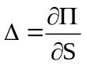
where 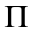 is the option price and S is underlying asset price. We next show the derivation of delta for various kinds of stock option.

30.2.1 Derivation of Delta for Different Kinds of Stock Options
From Black-Scholes option pricing model, we know the price of call option on a non-dividend stock can be written as:
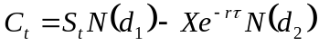 (30.1)
and the price of put option on a non-dividend stock can be written as:
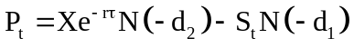 (30.2)
where
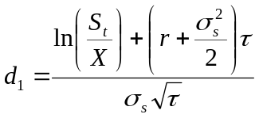
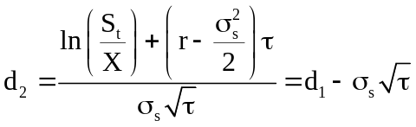
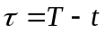
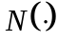 is the cumulative density function of normal distribution.
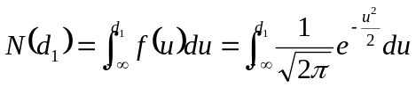

First, we calculate 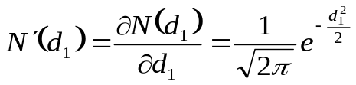 (30.3)
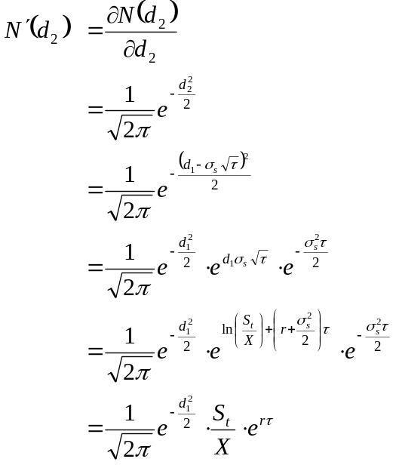 (30.4)
Eq. (30.2) and Eq. (30.3) will be used repetitively in determining following Greek letters when the underlying asset is a non-dividend paying stock.
For a European call option on a non-dividend stock, delta can be shown as
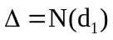 (30.5)
The derivation of Eq. (30.5) is in the following:
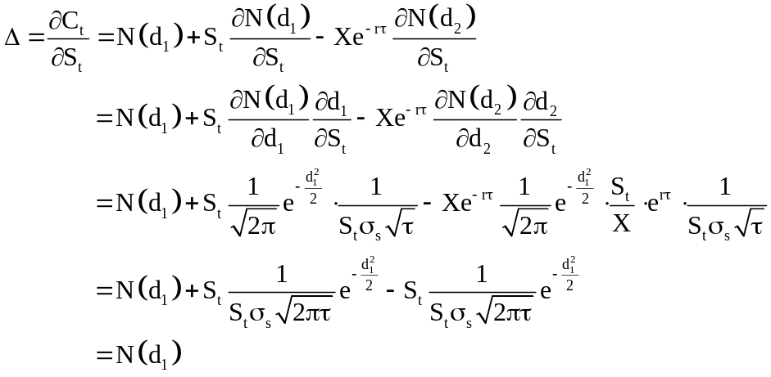

For a European put option on a non-dividend stock, delta can be shown as
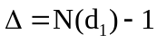 (30.6)
The derivation of Eq. (30.6) is
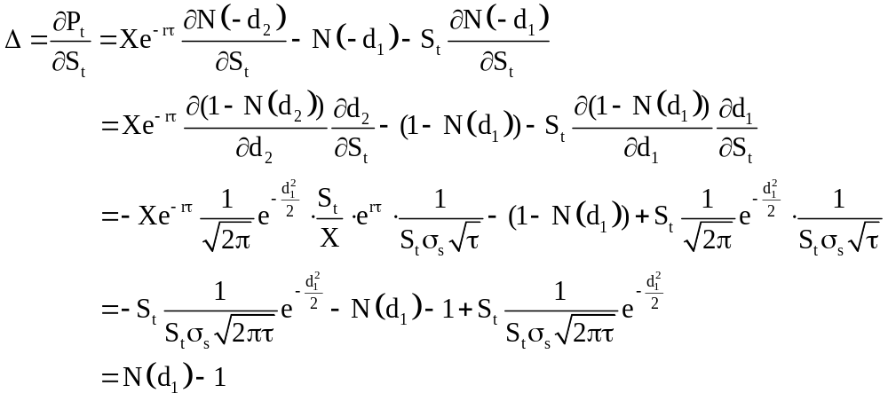

If the underlying asset is a dividend-paying stock providing a dividend yield at rate q, Black-Scholes formulas for the prices of a European call option on a dividend-paying stock and a European put option on a dividend-paying stock are
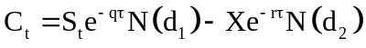 (30.7)
and
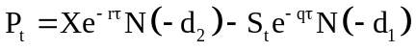 (30.8)
where
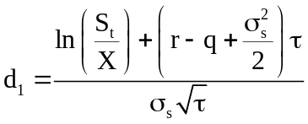
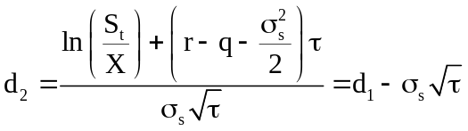
To make the following derivations more easily, we calculate Eq. (30.9) and Eq. (30.10) in advance.
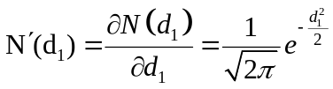 (30.9)
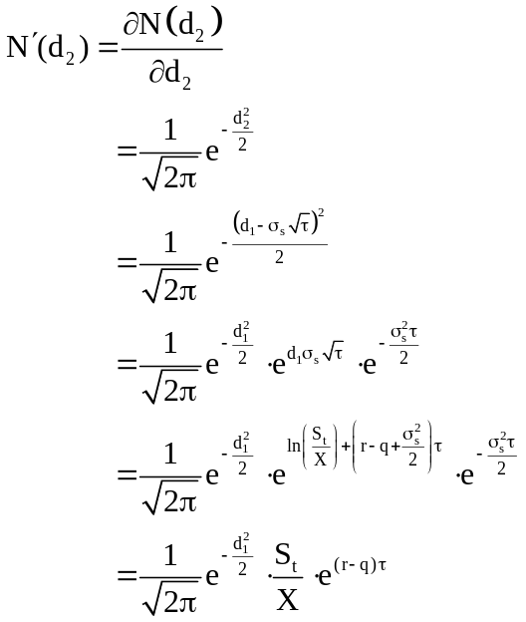 (30.10)

For a European call option on a dividend-paying stock, delta can be shown as
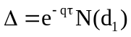 (30.11)
The derivation of (30.11) is
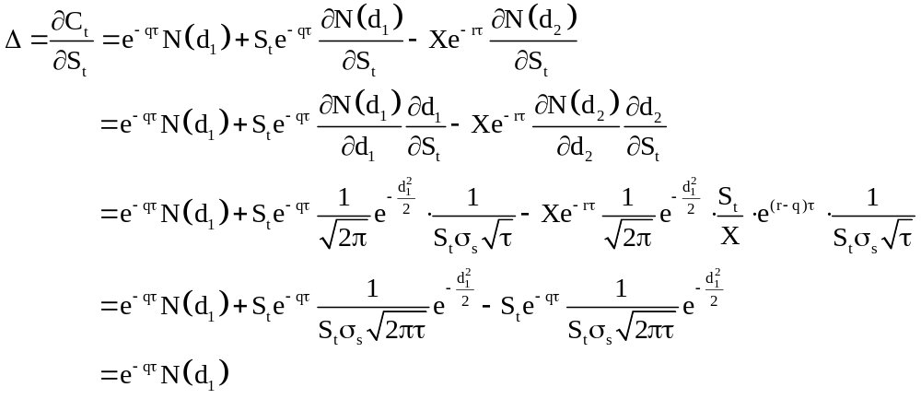
For a European call option on a dividend-paying stock, delta can be shown as
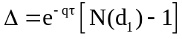 (30.12)
The derivation of (30.12) is
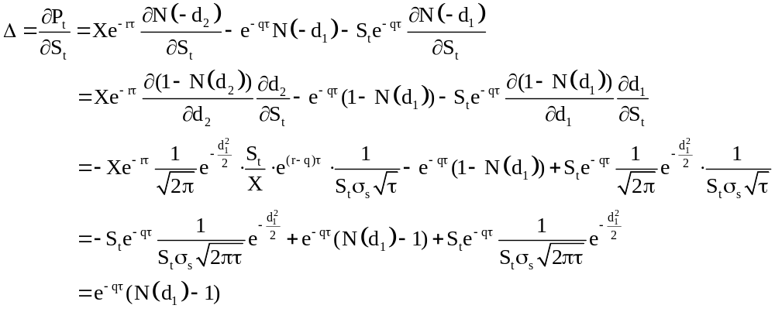

30.2.2 Application of Delta
Figure 30.1 shows the relationship between the price of a call option and the price of its underlying asset. The delta of this call option is the slope of the line at the point of A corresponding to current price of the underlying asset.
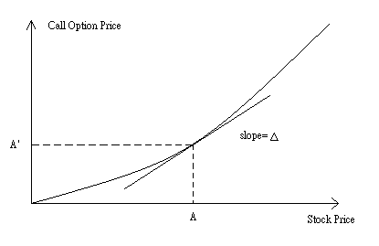
Figure 30.1
By calculating delta ratio, a financial institution that sells option to a client can make a delta neutral position to hedge the risk of changes of the underlying asset price. Suppose that the current stock price is $100, the call option price on stock is $10, and the current delta of the call option is 0.4. A financial institution sold 10 call option to its client, so that the client has right to buy 1,000 shares at time to maturity. To construct a delta hedge position, the financial institution should buy 0.4 x 1,000 = 400 shares of stock. If the stock price goes up to $1, the option price will go up by $0.4. In this situation, the financial institution has a $400 ($1 x 400 shares) gain in its stock position, and a $400 ($0.4 x 1,000 shares) loss in its option position. The total payoff of the financial institution is zero. On the other hand, if the stock price goes down by $1, the option price will go down by $0.4. The total payoff of the financial institution is also zero.
However, the relationship between option price and stock price is not linear, so delta changes over different stock price. If an investor wants to remain his portfolio in delta neutral, he should adjust his hedged ratio periodically. The more frequently adjustment he does, the better delta-hedging he gets.
Figure 30.2 exhibits the change in delta affects the delta-hedges. If the underlying stock has a price equal to $20, then the investor who uses only delta as risk measure will consider that his portfolio has no risk. However, as the underlying stock prices changes, either up or down, the delta changes as well and thus he will have to use different delta hedging. Delta measure can be combined with other risk measures to yield better risk measurement. We will discuss it further in the following sections.
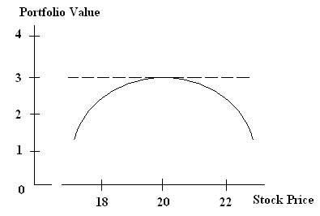
Figure 30.2

30.3 Theta (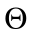)
The theta of an option, , is defined as the rate of change of the option price respected to the passage of time:
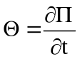
where is the option price and is the passage of time.
If 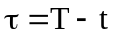, theta () can also be defined as minus one timing the rate of change of the option price respected to time to maturity. The derivation of such transformation is easy and straight forward:
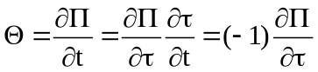
where is time to maturity. For the derivation of theta for various kinds of stock option, we use the definition of negative differential on time to maturity.

30.3.1 Derivation of Theta for Different Kinds of Stock Option
For a European call option on a non-dividend stock, theta can be written as:
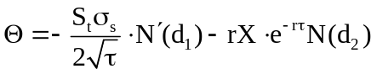 (30.13)
The derivation of (30.13) is
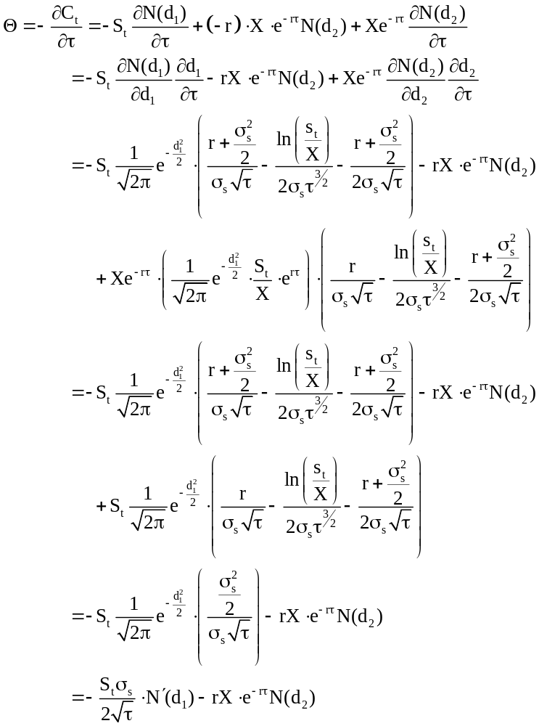

For a European put option on a non-dividend stock, theta can be shown as
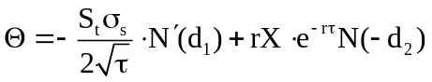 (30.14)
The derivation of (30.14) is
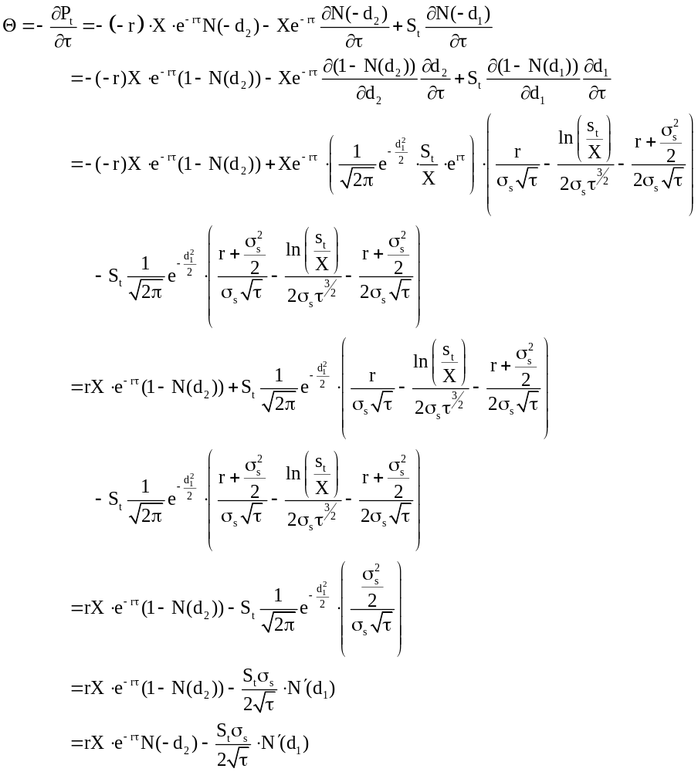

For a European call option on a dividend-paying stock, theta can be shown as
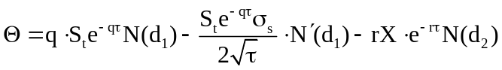 (30.15)
The derivation of (30.15) is
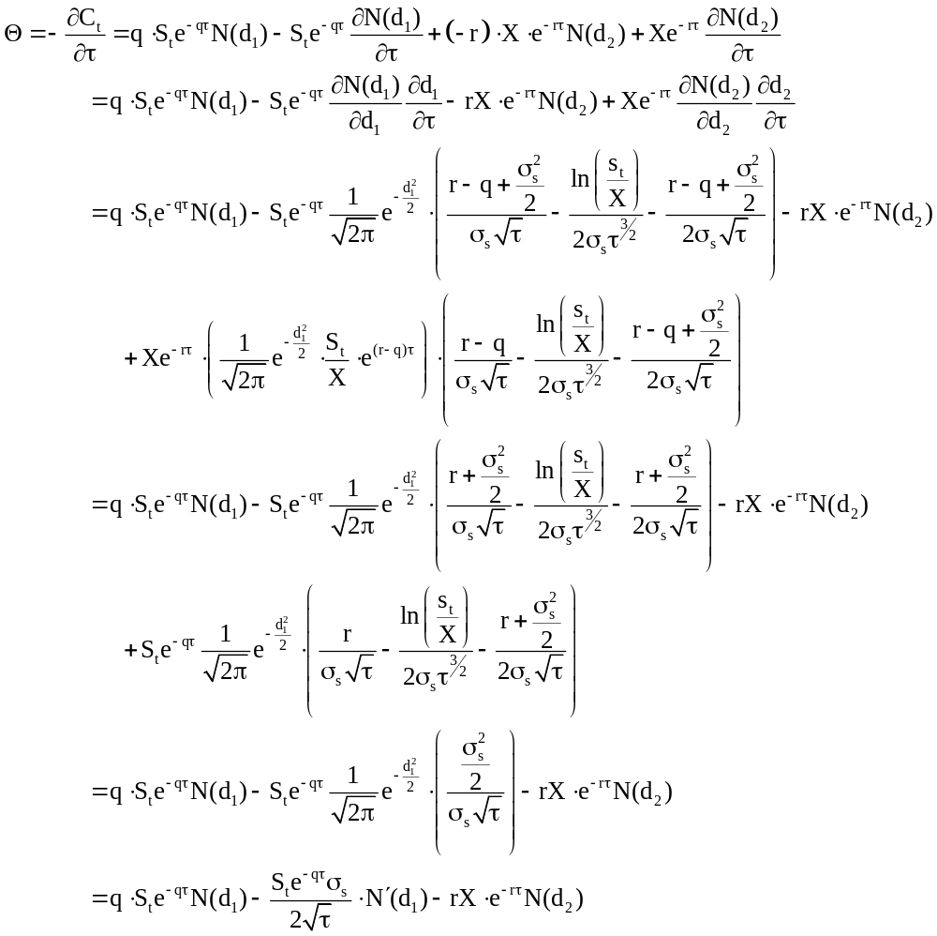
For a European call option on a dividend-paying stock, theta can be shown as
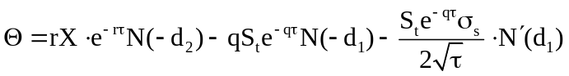 (30.16)
The derivation of (30.16) is
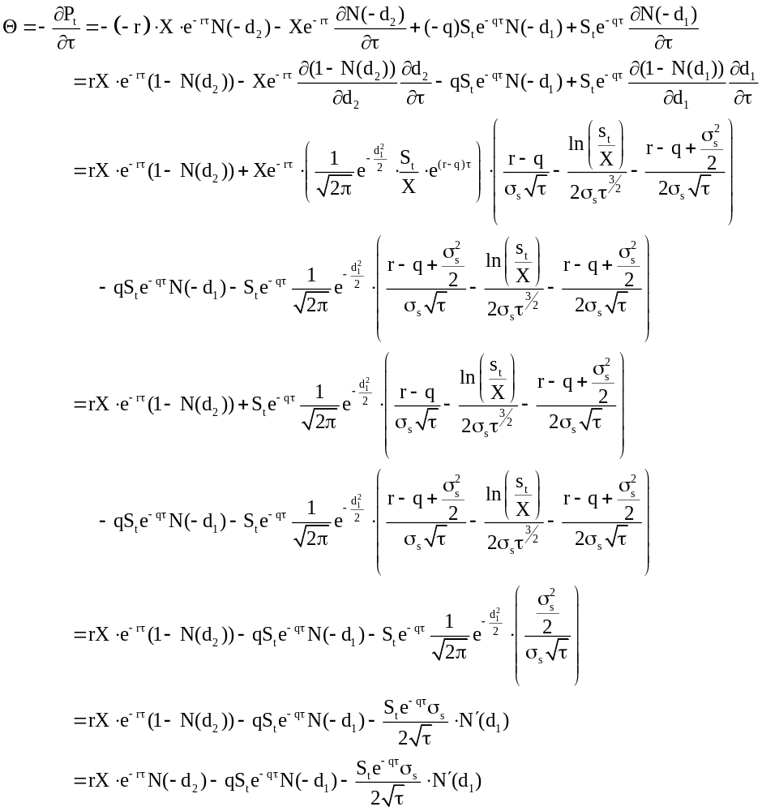
30.3.2 Application of Theta ()
The value of option is the combination of time value and stock value. When time passes, the time value of the option decreases. Thus, the rate of change of the option price with respective to the passage of time, theta, is usually negative.
Because the passage of time on an option is not uncertain, we do not need to make a theta hedge portfolio against the effect of the passage of time. However, we still regard theta as a useful parameter, because it is a proxy of gamma in the delta neutral portfolio. For the specific detail, we will discuss in the following sections.

30.4 Gamma ()
The gamma of an option, , is defined as the rate of change of delta respected to the rate of change of underlying asset price::
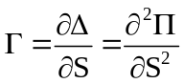
where is the option price and S is the underlying asset price.
Because the option is not linearly dependent on its underlying asset, delta-neutral hedge strategy is useful only when the movement of underlying asset price is small. Once the underlying asset price moves wider, gamma-neutral hedge is necessary. We next show the derivation of gamma for various kinds of stock option.

30.4.1 Derivation of Gamma for Different Kinds of Stock Option
For a European call option on a non-dividend stock, gamma can be shown as
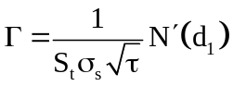 (30.17)
The derivation of (30.17) is
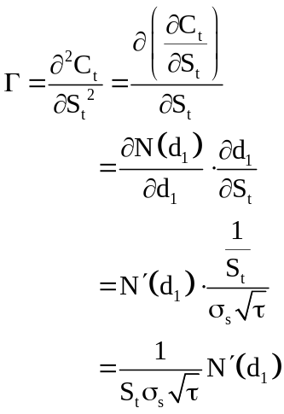

For a European put option on a non-dividend stock, gamma can be shown as
(30.18)
The derivation of (30.18) is
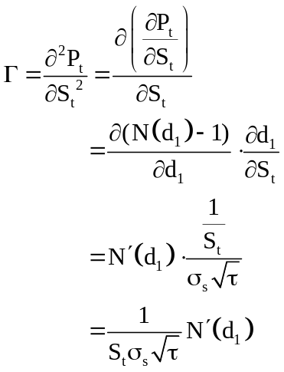
For a European call option on a dividend-paying stock, gamma can be shown as
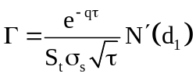 (30.19)
The derivation of (30.19) is
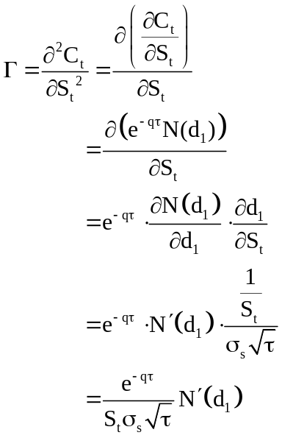

For a European call option on a dividend-paying stock, gamma can be shown as
(30.20)
The derivation of (30.20) is
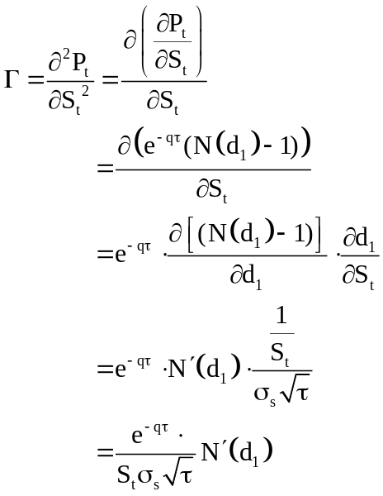

30.4.2 Application of Gamma ()
One can use delta and gamma together to calculate the changes of the option due to changes in the underlying stock price. This change can be approximated by the following relations.
From the above relation, one can observe that the gamma makes the correction for the fact that the option value is not a linear function of underlying stock price. This approximation comes from the Taylor series expansion near the initial stock price. If we let V be option value, S be stock price, and S₀ be initial stock price, then the Taylor series expansion around S₀ yields the following.
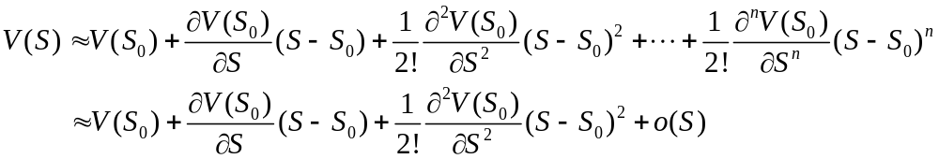
If we only consider the first three terms, the approximation is then,
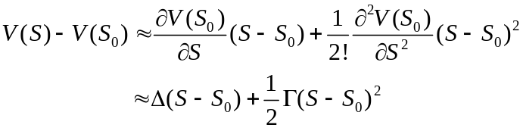.
For example, if a portfolio of options has a delta equal to $10000 and a gamma equal to $5000, the change in the portfolio value if the stock price drop to $34 from $35 is approximately,
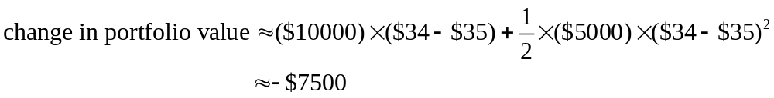
The above analysis can also be applied to measure the price sensitivity of interest rate related assets or portfolio to interest rate changes. Here we introduce Modified Duration and Convexity as risk measure corresponding to the above delta and gamma. Modified duration measures the percentage change in asset or portfolio value resulting from a percentage change in interest rate.
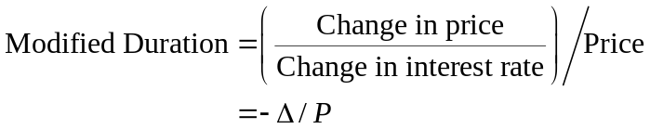
Using the modified duration,
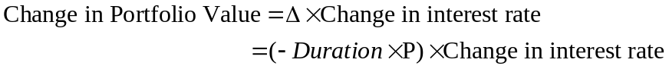
we can calculate the value changes of the portfolio. The above relation corresponds to the previous discussion of delta measure. We want to know how the price of the portfolio changes given a change in interest rate. Similar to delta, modified duration only show the first order approximation of the changes in value. In order to account for the nonlinear relation between the interest rate and portfolio value, we need a second order approximation similar to the gamma measure before, this is then the convexity measure. Convexity is the interest rate gamma divided by price,
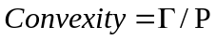
and this measure captures the nonlinear part of the price changes due to interest rate changes. Using the modified duration and convexity together allow us to develop first as well as second order approximation of the price changes similar to previous discussion.
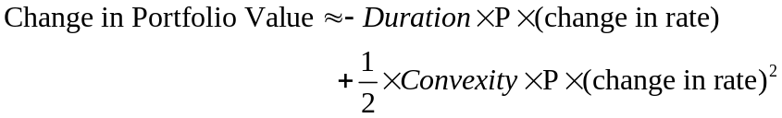
As a result, (-duration x P) and (convexity x P) act like the delta and gamma measure respectively in the previous discussion. This shows that these Greeks can also be applied in measuring risk in interest rate related assets or portfolio.
Next we discuss how to make a portfolio gamma neutral. Suppose the gamma of a delta-neutral portfolio is , the gamma of the option in this portfolio is 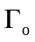, and 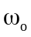 is the number of options added to the delta-neutral portfolio. Then, the gamma of this new portfolio is
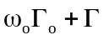
To make a gamma-neutral portfolio, we should trade 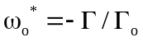 options. Because the position of option changes, the new portfolio is not in the delta-neutral. We should change the position of the underlying asset to maintain delta-neutral.
For example, the delta and gamma of a particular call option are 0.7 and 1.2. A delta-neutral portfolio has a gamma of -2,400. To make a delta-neutral and gamma-neutral portfolio, we should add a long position of 2,400/1.2=2,000 shares and a short position of 2,000 x 0.7=1,400 shares in the original portfolio.

30.5 Vega ()
The vega of an option, , is defined as the rate of change of the option price respected to the volatility of the underlying asset:
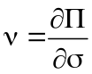
where is the option price and is volatility of the stock price. We next show the derivation of vega for various kinds of stock option.

30.5.1 Derivation of Vega for Different Kinds of Stock Option
For a European call option on a non-dividend stock, vega can be shown as
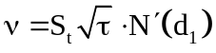 (30.21)
The derivation of (30.21) is
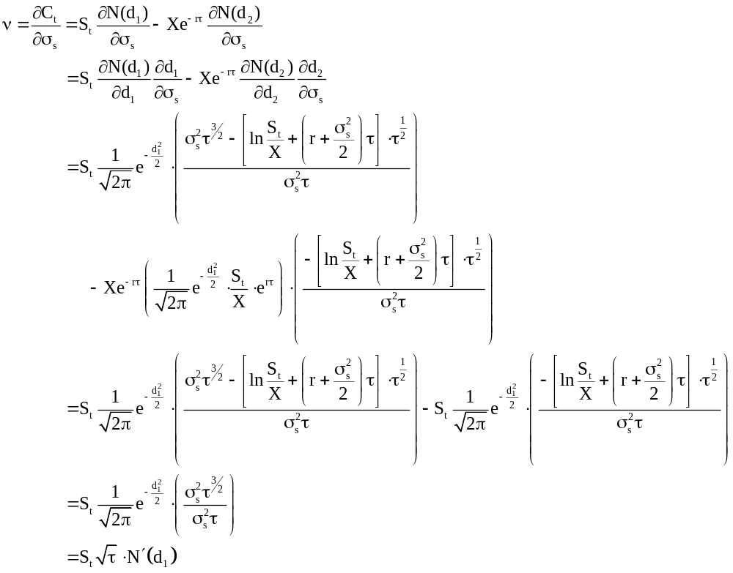
For a European put option on a non-dividend stock, vega can be shown as
(30.22)
The derivation of (30.22) is
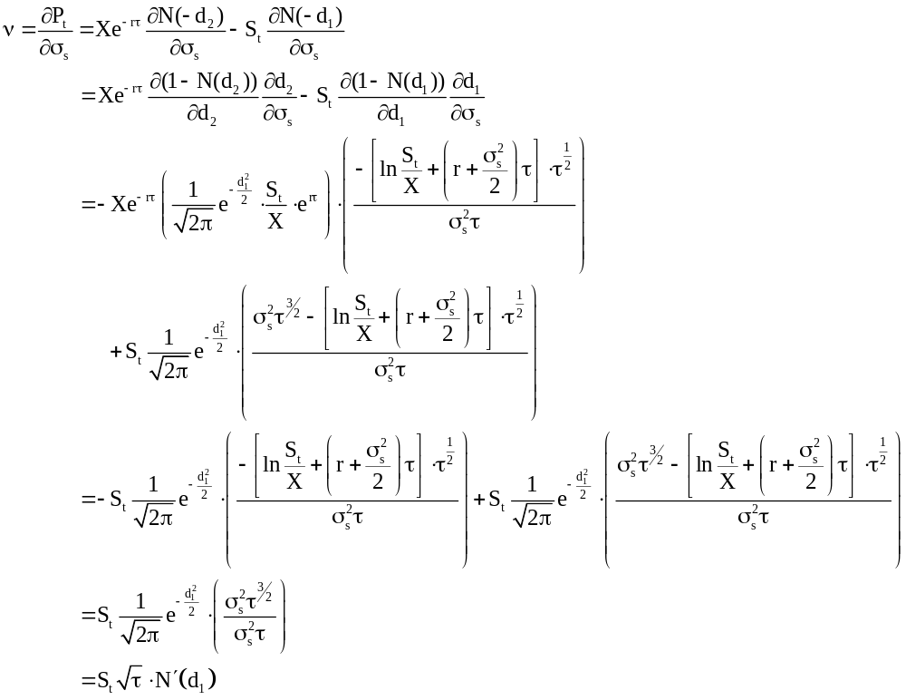
For a European call option on a dividend-paying stock, vega can be shown as
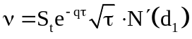 (30.23)
The derivation of (30.23) is
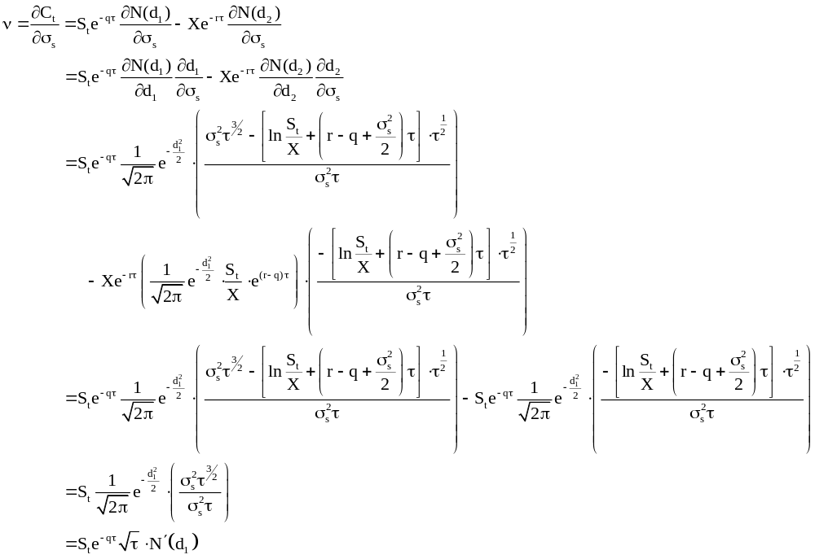
For a European call option on a dividend-paying stock, vega can be shown as
(30.24)
The derivation of (30.24) is
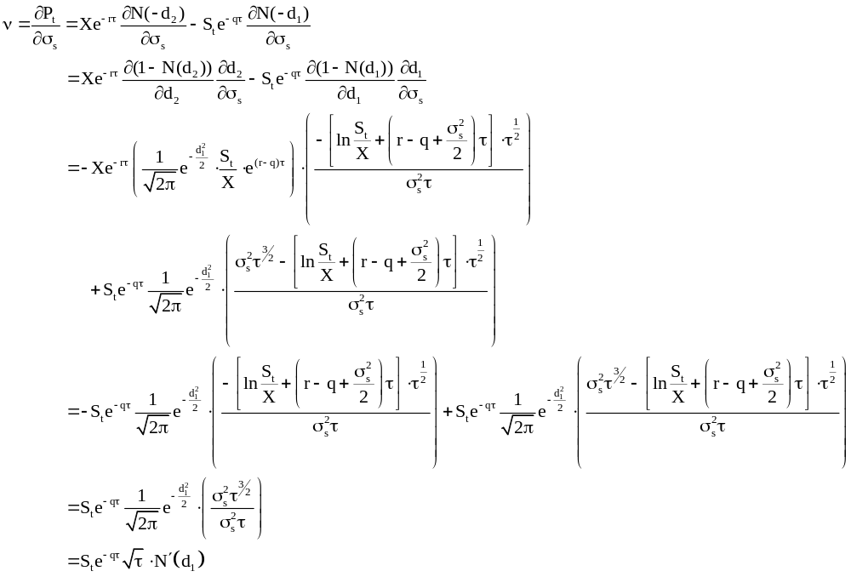
30.5.2 Application of Vega ()
Suppose a delta-neutral and gamma-neutral portfolio has a vega equal to and the vega of a particular option is 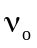. Similar to gamma, we can add a position of 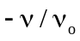 in option to make a vega-neutral portfolio. To maintain delta-neutral, we should change the underlying asset position. However, when we change the option position, the new portfolio is not gamma-neutral. Generally, a portfolio with one option cannot maintain its gamma-neutral and vega-neutral at the same time. If we want a portfolio to be both gamma-neutral and vega-neutral, we should include at least two kind of option on the same underlying asset in our portfolio.
For example, a delta-neutral and gamma-neutral portfolio contains option A, option B, and underlying asset. The gamma and vega of this portfolio are -3,200 and -2,500, respectively. Option A has a delta of 0.3, gamma of 1.2, and vega of 1.5. Option B has a delta of 0.4, gamma of 1.6 and vega of 0.8. The new portfolio will be both gamma-neutral and vega-neutral when adding 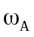 of option A and 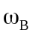 of option B into the original portfolio.
From two equations shown above, we can get the solution that =1000 and = 1250. The delta of new portfolio is 1000 x .3 + 1250 x 0.4 = 800. To maintain delta-neutral, we need to short 800 shares of the underlying asset.

30.6 Rho ()
The rho of an option is defined as the rate of change of the option price respected to the interest rate:
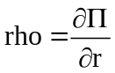
where is the option price and r is interest rate. The rho for an ordinary stock call option should be positive because higher interest rate reduces the present value of the strike price which in turn increases the value of the call option. Similarly, the rho of an ordinary put option should be negative by the same reasoning. We next show the derivation of rho for various kinds of stock option.

30.6.1 Derivation of Rho for Different Kinds of stock option
For a European call option on a non-dividend stock, rho can be shown as
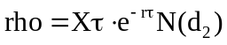 (30.25)
The derivation of (30.25) is
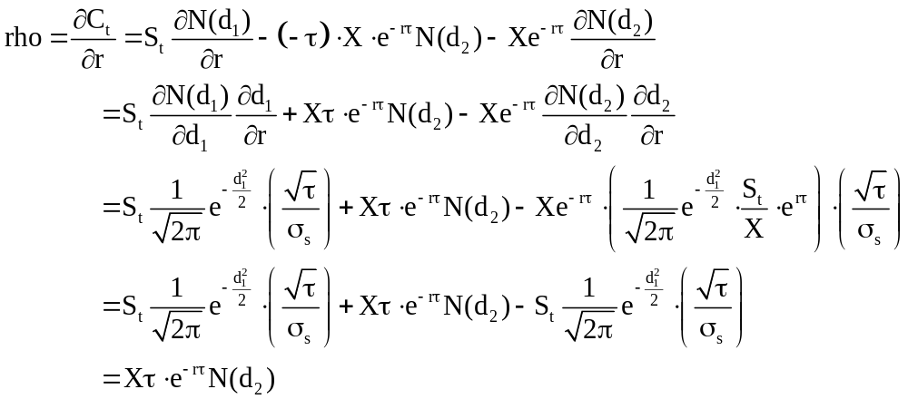

For a European put option on a non-dividend stock, rho can be shown as
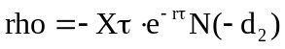 (30.26)
The derivation of (30.26) is
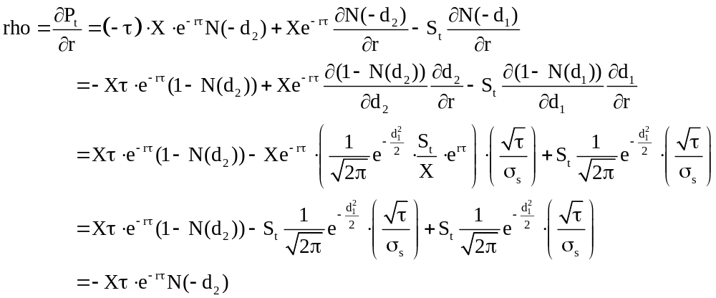
For a European call option on a dividend-paying stock, rho can be shown as
(30.27)
The derivation of (30.27) is
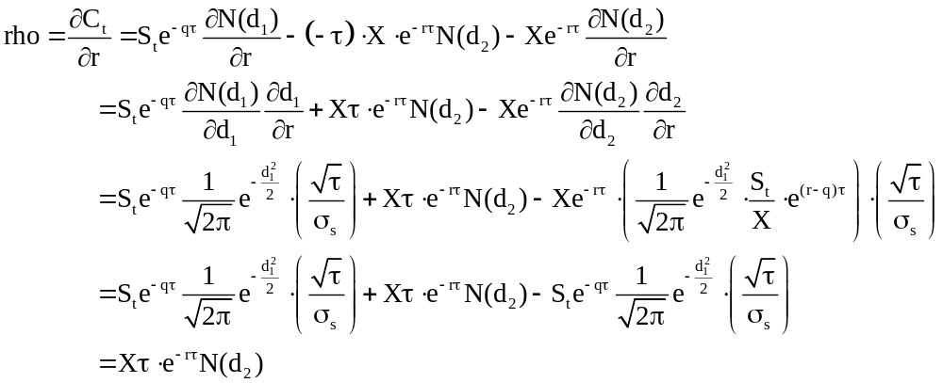

For a European put option on a dividend-paying stock, rho can be shown as
(30.28)
The derivation of (30.28) is
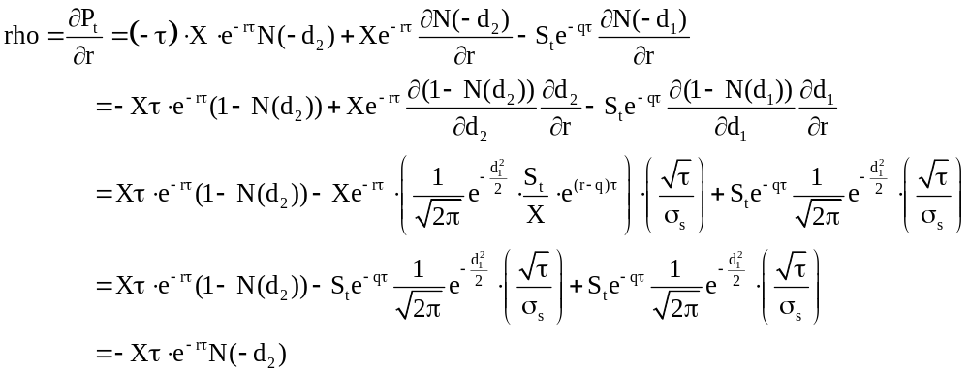
30.6.2 Application of Rho ()
Assume that an investor would like to see how interest rate changes affect the value of a 3-month European put option she holds with the following information. The current stock price is $65 and the strike price is $58. The interest rate and the volatility of the stock is 5% and 30% per annum respectively. The rho of this European put can be calculated as following.
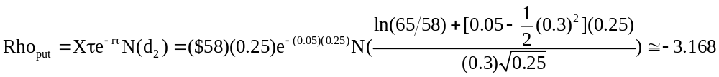
This calculation indicates that given 1% change increase in interest rate, say from 5% to 6%, the value of this European call option will decrease 0.03168 (0.01 x 3.168). This simple example can be further applied to stocks that pay dividends using the derivation results shown previously.

30.7 Derivation of Sensitivity for Stock Options Respective with Exercise Price
For a European call option on a non-dividend stock, the sensitivity can be shown as
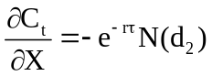 (30.29)
The derivation of (30.29) is
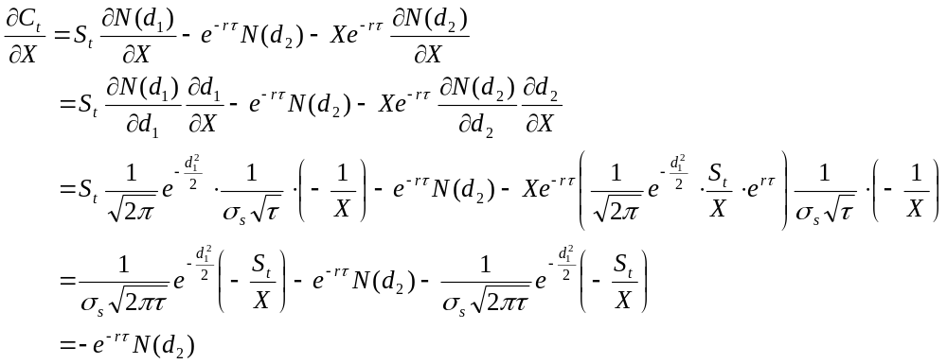
For a European put option on a non-dividend stock, the sensitivity can be shown as
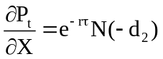 (30.30)
The derivation of (30.30) is
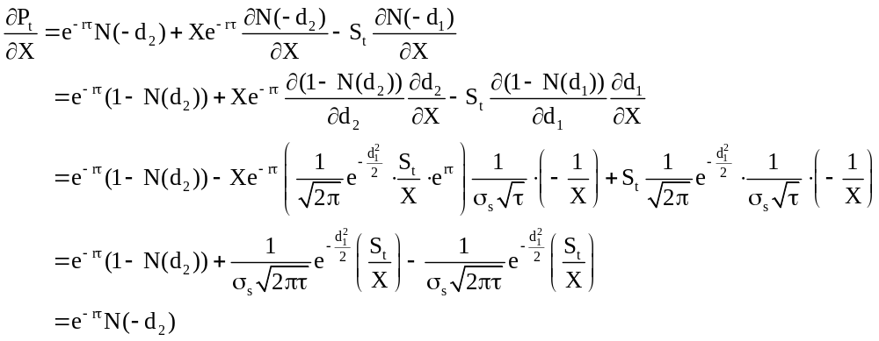
For a European call option on a dividend-paying stock, the sensitivity can be shown as
(30.31)
The derivation of (30.31) is
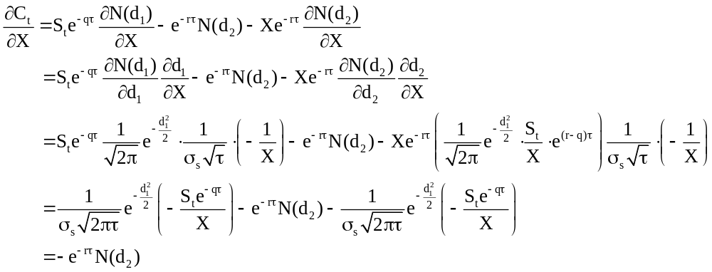
For a European put option on a dividend-paying stock, the sensitivity can be shown as
(30.32)
The derivation of (30.32) is
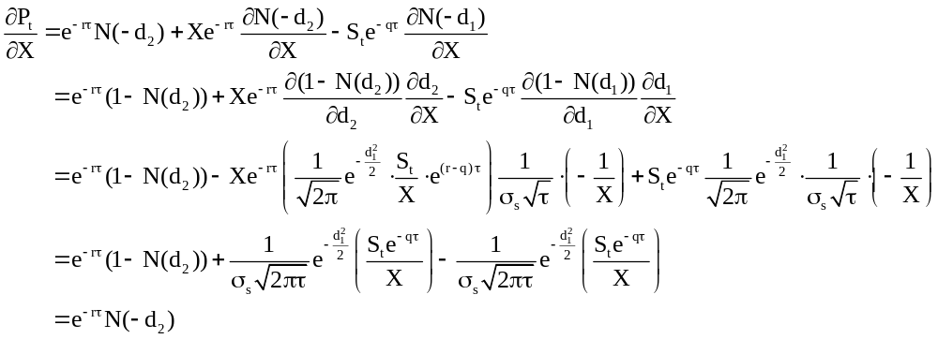
30.8 Relationship between Delta, Theta, and Gamma
So far, the discussion has introduced the derivation and application of each individual Greeks and how they can be applied in portfolio management. In practice, the interaction or trade-off between these parameters is of concern as well. For example, recall the partial differential equation for the Black-Scholes formula with non-dividend paying stock can be written as
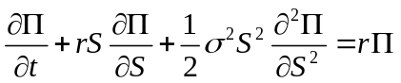
Where is the value of the derivative security contingent on stock price, S is the price of stock, r is the risk free rate, and is the volatility of the stock price, and t is the time to expiration of the derivative. Given the earlier derivation, we can rewrite the Black-Scholes PDE as
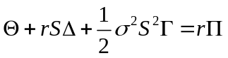
This relation gives us the trade-off between delta, gamma, and theta. For example, suppose there are two delta neutral 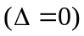 portfolios, one with positive gamma 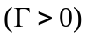and the other one with negative gamma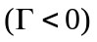 and they both have value of $1 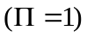. The trade-off can be written as
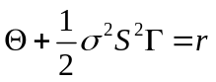
For the first portfolio, if gamma is positive and large, then theta is negative and large. When gamma is positive, change in stock prices result in higher value of the option. This means that when there is no change in stock prices, the value of the option declines as we approach the expiration date. As a result, the theta is negative. On the other hand, when gamma is negative and large, change in stock prices result in lower option value. This means that when there is no stock price changes, the value of the option increases as we approach the expiration and theta is positive. This gives us a trade-off between gamma and theta and they can be used as proxy for each other in a delta neutral portfolio.

30.9 Conclusion
In this chapter we have shown the derivation of the sensitivities of the option price to the change in the value of state variables or parameters. The first Greek is delta () which is the rate of change of option price to change in price of underlying asset. Once the delta is calculated, the next step is the rate of change of delta with respect to underlying asset price which gives us gamma (). Another two risk measures are theta () and rho (), they measure the change in option value with respect to passing time and interest rate respectively. Finally, one can also measure the change in option value with respect to the volatility of the underlying asset and this gives us the vega ().
The relationship between these risk measures are shown, one of the example can be seen from the Black-Scholes partial differential equation. Furthermore, the applications of these Greeks letter in the portfolio management have also been discussed. Risk management is one of the important topics in finance today, both for academics and practitioners. Given the recent credit crisis, one can observe that it is crucial to properly measure the risk related to the ever more complicated financial assets.

References
Bjork, T., Arbitrage Theory in Continuous Time, Oxford University Press, 1998.

Boyle, P. P., & Emanuel, D. (1980). Discretely adjusted option hedges. Journal of Financial Economics, 8(3), 259-282.

Duffie, D., Dynamic Asset Pricing Theory, Princeton University Press, 2001.

Fabozzi, F.J., Fixed Income Analysis, 2nd Edition, Wiley, 2007.

Figlewski, S. (1989). Options arbitrage in imperfect markets. Journal of Finance, 44(5), 1289-1311.

Galai, D. (1983). The components of the return from hedging options against stocks. Journal of Business, 56(1), 45-54.

Hull, J., Options, Futures, and Other Derivatives 6th Edition, Pearson, 2006.

Hull, J., & White, A. (1987). Hedging the risks from writing foreign currency options. Journal of International Money and Finance, 6(2), 131-152.

Karatzas, I. and Shreve, S.E., Brownian Motion and Stochastic Calculus, Springer, 2000.

Klebaner, F.C., Introduction to Stochastic Calculus with Applications, Imperial College Press, 2005.

McDonlad, R.L., Derivatives Markets 2nd Edition, Addison-Wesley, 2005.

Shreve, S.E., Stochastic Calculus for Finance II: Continuous Time Model, Springer, 2004.

Tuckman, B., Fixed Income Securities: Tools for Today's Markets, 2nd Edition, Wiley, 2002.

